# **Epson 12000xl**

# Guide to Scanning Photographs

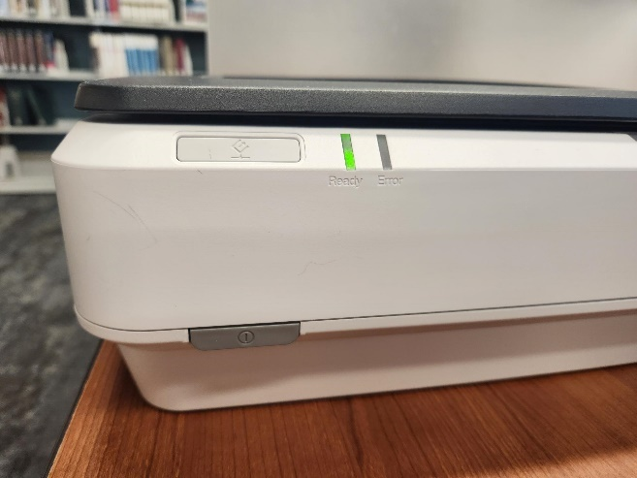

*Getting started*

* Sign into the computer using either your library card or a guest pass.
* Connect your flash drive or external hard drive to the computer.
* Turn the scanner on, the indicator light should be a solid green.
* Lift the lid of the scanner.
* Ensure that the white, reflective document mat is in place.
  + If it is not, please ask a staff member for help.
* Make sure the glass of the scanner bed is clean and free of dust (see cleaning guide).
* Place your photo(s) face down on the glass.
  + Note: If you are scanning multiple photos at once, position each item at least 3/4 of an inch apart.
* 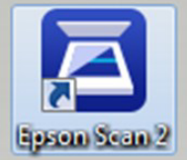Close the lid gently.
  + Note: Do not leave originals on the scanner glass for an extended period   
    of time or they may stick to the glass.
* On the computer desktop, double-click on the icon labeled Epson Scan 2.

*Settings*

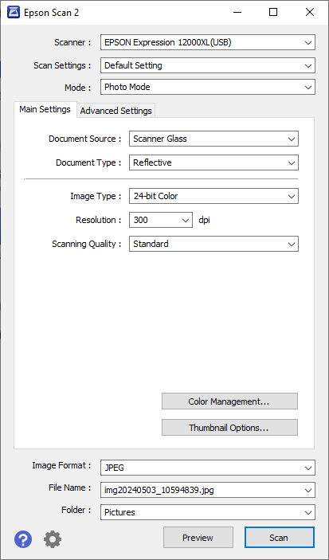Mode: Photo Mode

Main Settings:

* + Image type: Black & White or Color
  + Resolution: The appropriate resolution may vary.
    - Between 300-600 is a good range for archiving photos.
    - Scanning Quality: Standard or High
    - High Quality are best used for slides or detailed images.
* File Settings:
  + Image Format: JPEG, PNG, TIFF, PDF   
    (see recommendations)
  + File Name: You can assign the image names by date and/or by number.
    - This can be any number.

Folder: The Pictures folder on the C: Drive is the default save location.

You can copy the images from the Pictures folder to your personal device, or set the save folder as your personal device.

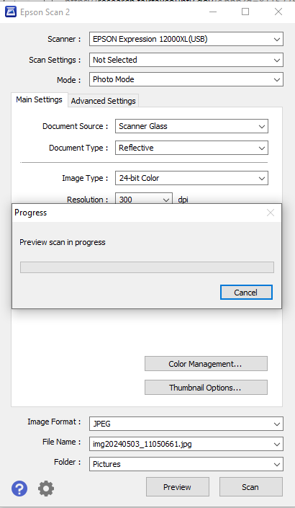*Scanning*

* Select preview so that you can see how the images will scan before you save them as files.
  + The previewed images should display as **Thumbnails**.
    - Note: Since the photographs appear as individual image, you can remove any images for photos you do not wish to scan without removing the photographs from the scanner.
* When you are satisfied with how the images appear in the preview thumbnails, select Scan.
  + A message will appear on screen to indicate when your scan is complete. Do not lift the lid of the scanner until this message appears.
* Remember to take your originals with you when you leave - check the scanner glass and the area around you.
* 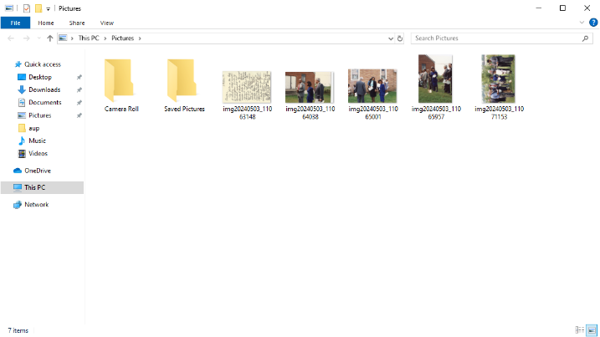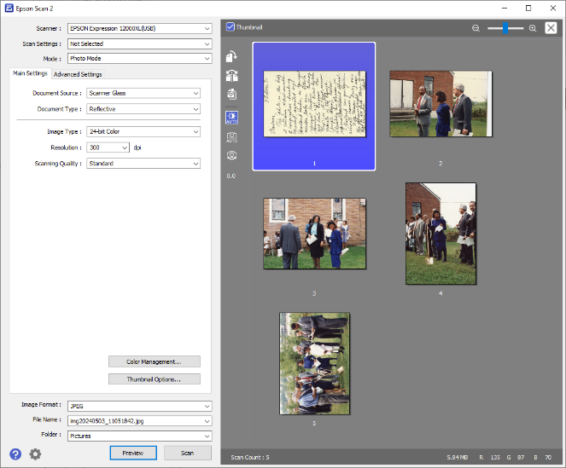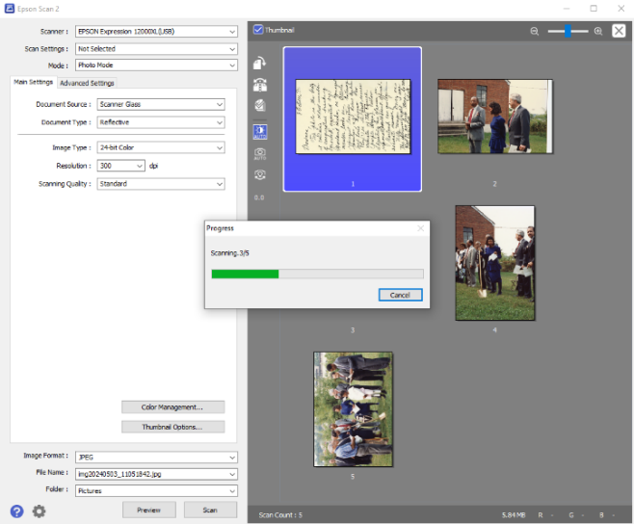Power down the scanner and log off of the computer.

**NO** files are kept on this computer after your session ends and you are logged off of the computer.

Make sure your image files are saved to your device before you log off.