**Advanced Settings**

You can adjust the scanned image using detailed settings which are suitable for photos or pictures, such as the following.

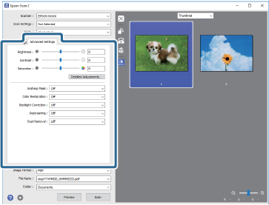

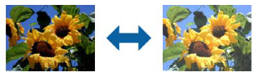

❏ **Brightness**: Select to adjust the brightness for the scanned image.

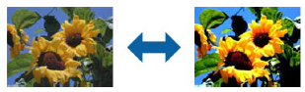

❏ **Contrast**: Select to adjust the contrast for the scanned image.

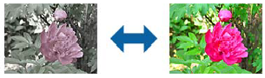

❏ **Saturation**: Select to adjust the saturation (color vividness) for the scanned image.

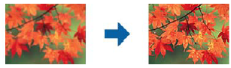

❏ **Unsharp Mask**: Select to enhance and sharpen the outlines for the scanned image.

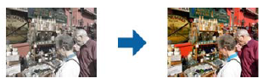❏ **Color Restoration**: Select to correct images that have faded to return them to their original colors.

***Note:*** *Depending on the state of the original, it may not be corrected correctly. In this situation, adjust from the* ***Detailed Adjustments*** *screen.*

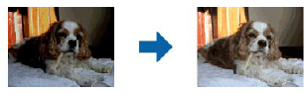

❏ **Backlight Correction**: Select to lighten scanned images that are dark due to backlight.

***Note:*** *Depending on the state of the original, it may not be corrected correctly. In this situation, adjust from the* ***Detailed Adjustments*** *screen.*

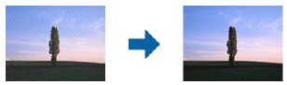❏ **Descreening**: Select to remove moiré patterns (web-like shadows) that appear when scanning printed

papers such as a magazine.

To check for moiré patterns, display the image at 100 % (1:1). If the displayed image is zoomed out, the image

appears rough and may look like it has moiré patterns.

***Note:***

❏ *To use this feature, set the* ***Resolution*** *on the* ***Main Settings*** *tab to 600 dpi or less.*

❏ *This feature is not available when selecting the* ***Main Settings*** *tab >* ***Image Type*** *>* ***Black & White****.*

❏ *This feature is not available when scanning films.*

❏ *The effect of this feature cannot be checked in the preview window.*

❏ *This feature softens the sharpness of the scanned image.*

❏ **Dust Removal**: Select to remove dust on the scanned image.

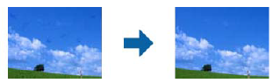***Note:***

❏ *Depending on the state of the original, it may not be corrected completely.*

❏ *The effect of this feature cannot be checked in the preview window.*

❏ *If the amount of free space in the memory is running low, you may not be able to scan.*

***Note:***

❏ *Some items may not be available depending on other settings you made.*

❏ *Depending on the original, the scanned image may not be adjusted correctly.*

❏ *When multiple thumbnails are created, you can adjust the image quality for each thumbnail. Depending on the*

*adjustment items, you can adjust the quality of scanned images at the same time by selecting multiple thumbnails.*